|  |  |  |
| --- | --- | --- |
| **LAB101 Assignment** | **Type:** | **Short Assignment** |
| **Code:** | **C.S.P0013** |
| **LOC:** | **80** |
| **Slot(s):** | **2** |

**Title**

Data Analysis.

**Background Context**

This assignment pertains to statistical analysis for a given data sample. In statistics, a collection of data values is usually referred to as a distribution. A primary purpose of statistical analysis is to find ways to compress the complete set of data into summary statistics that express properties of the distribution as a whole.

**Program Specifications**

Your program should read in a set of grades (that are all integers) entered by the user. The user will signify the end of the list of grades by entering -999. Do NOT process this value. You can assume that the user will enter at least three grades and not more than 100 grades, all of which will be integers in between 0 and 100, inclusive. For the set of grades, your program should compute the minimum value, print this out to two decimal places and remove it from the data. Then your program should compute the maximum value, print it out to two decimal places and remove it from the data. Then, your program should calculate the mean and standard deviation for the remaining set of grades, and print these out to two decimal places. Finally, a histogram for this data (without the highest and lowest grades) should be printed out as well.

***Function details:***

1. Function 1: This function reads an unknown number of grades (maximum of 100) into the array grades and counts the data items that have been read. You are not supposed to prompt the user to enter the grades. Just use scanf to read in the grades. The end of the input is represented by a negative number –999 This function reads an unknown number of grades (maximum of 100) into the array grades and counts the data items that have been read. You are not supposed to prompt the user to enter the grades. Just use scanf to read in the grades. The end of the input is represented by a negative number –999.
2. Function 2: Given an array of real numbers, this function finds out frequency (number of students) for each interval 0-4, 5-9,…..,95 – 99, 100 prints out the frequency values and plots the histogram.
3. Function 3: Given an array of real numbers and the effective size of the array (i.e. count of the numbers in the array), this function returns the location of the highest number in the array.
4. Function 4: Given an array of real numbers and the effective size of the array (i.e. count of the numbers in the array), this function returns the location of the lowest number in the array
5. Function 5: Given an array of real numbers, the effective size of the array and the location of the element to be deleted, this function deletes that element from the array and decrements the effective size, n, by one
6. Function 6: Given an array of numbers and the effective size of the array this function computes and returns the mean
7. Function 7: Given an array of numbers and the effective size of the array, this function computes and returns the standard deviation as described in the previous section

***Expectation of User interface:***

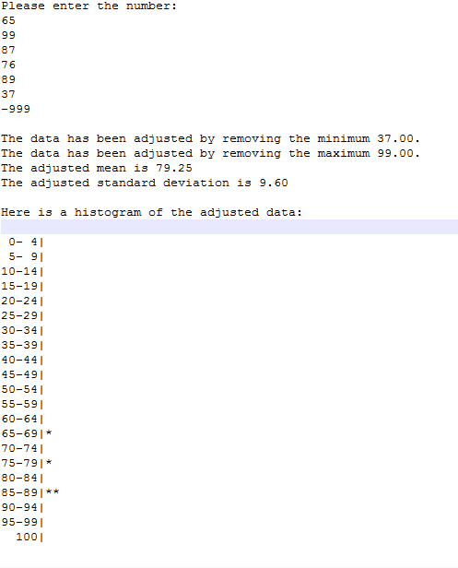

**Guidelines**

The most common statistical measure is the mean, which is simply the traditional average. For the distribution x1, x2, … xn, the mean is usually represented by the symbol

Another common statistical measure is the standard deviation, which provides an indication of how much the individual values in the distribution differ from the mean. To calculate the standard deviation whose elements are x1, x2, … xn you need to perform the following steps:

1. Calculate the mean of the distribution.
2. Go through the individual data items in the distribution and calculate the square of the difference between each data value and the mean. Add all these values to a running total.
3. Take the total from step b and divide it by the number of data items.
4. Calculate the square root of the resulting quantity, which represents the standard deviation.

In mathematical form, the standard deviation (σ) is given by the following formula:

σ= 

A histogram gives us a pictorial view of the data. Basically it is a frequency plot. For example given a histogram of a set of marks of students in a class, we can immediately see whether there were more students in the range 50-54 or 80-84 and so on. To draw a histogram, first decide upon the intervals. Let us say the interval is 5. Then count the number of students getting marks in the intervals 0-4, 5-9, 10-14, 15-19, 20-24, 25-29 and so on. The last interval will contain a single integer. Now you are ready to draw the histogram or the frequency plot. Here is an example of a histogram plot:

0– 4 |****************

5- 9 |***********************

10-14|******************************

15-19|*************************************

20-24|**********************

25-29|*************

30-34|*********

35-39|****

40-44|**

45-49|*

50 |**